Effect of Engineering Training on Teamwork Skills in a Multi-user Virtual Reality Platform
Peng Wang, onlymay@swu.edu.cn
School of Engineering and Technology, Southwest University, Chongqing, China
Peng Wu, peng.wu@curtin.edu.au
School of Design and the Built Environment, Faculty of Humanities, Curtin University, Australia

Abstract
Due to the rapid evolvement from the technology at Architecture, Engineering & Construction (AEC) fields, providing sufficient training programmes to improve collaborative construction skills of employees has played an important role in the industry. Collaboration during the learning process is regarded as an important factor that contributes to student learning. VR-enabled training provides an efficient environment for trainees. However, there is a lack of studies on how VR collaborative training strategies can be evaluated and improved with productivity concerns. The purpose of this study is to evaluate the effect of VR collaborative training on teamwork skills, including coordination, decision making, leadership, adaptability and communication. The results indicate that VR collaborative training exercise can have positive effect on teamwork skills, especially in coordination, decision making, adaptability and communication, but there is no significant difference in leadership and interpersonal skill after VR collaborative training exercise.

Keywords: Virtual Reality, Teamwork, Collaborative training

1 Introduction
Teamwork skills is becoming an increasingly important part of engineering training and education. As Zhao et al. (2015) pointed out, construction trainees are required to have certain non-technical competencies such as innovative, adaptive and collaborative. The trainees who gain experience from the construction collaborative and productivity training are more competitive in the workforce. Current training programmes in the construction industry are based on traditional methods, including on-the-job training and information-based training.
Virtual Reality (VR) is believed to be effective in improving the quality of construction engineering training and education programmes. Comparing with the training approaches mentioned above, VR-enabled training provides an efficient environment for trainees to rehearse their operations without limitations of time, constraints of physical presentations, and potential high expenses on setting up the environment. Studies confirmed that VR training system can be used to create effective training activities for the construction industry. VR training also stimulates learning and promotes trainee interaction. However, current VR-based training studies in the construction industry tend to focus more on improving the individual training experience (Du et al., 2017). It is controversial to the situation at operation sites where workers’ collaboration carries out most of the construction or maintenance tasks. Despite some researchers have developed VR training systems on collaborative tasks for multiuser in recent years, they seldom discuss what would be the problems of the collaborative training through traditional training such as video and lecture based training. Also, there is a lack of studies on how VR collaborative training strategies can be evaluated and improved with productivity concerns. Li et al. (2012) developed a multiuser virtual safety training system for tower crane dismantlement to enhance trainees’ practical knowledge. Vahdatikhaki et al., (2019) proposed a framework to integrate actual construction project data into a VR training system for multiple trainees to enhance construction safety and teamwork. These studies focus on the isolated application of VR to address a specific training need. The concerns of considering how to improve workforce collaborative competencies and behavior through training are not addressed here.

2. literature review

2.1 Teamwork skills for training collaboration
A team is composed of individuals, as two or more people working together to accomplish a common task or achieve a shared goal (Cohen & Bailey, 1997). Individuals in team should cooperate and dynamically adjust their efforts according to the dynamic performance of other team members to achieve this goal (Rosen et al., 2010). The outcome of teamwork must consider not only the final results of the task, but how the individuals achieve the results. O’Neil et al., (1997) stated that individuals of an effective team need to be prepared for tasks in teamwork and should know how to coordinate team activities, communicate effectively with other team members and respond to changing conditions in team process. O’Neil et al., (1997) identified six teamwork competencies that are necessary to the effective team, including Adaptability, Coordination, Decision-making, Interpersonal, Leadership and Communication.

2.2 VR for construction worker’s collaborative training
Construction workers’ collaboration is important to any construction project. The effective collaboration of construction worker can ensure the construction quality and complete the project on time with the budget (Mitropoulos & Memarian, 2012). Therefore, the cooperation of the construction workers in the team directly affects the efficiency of the project and leads to lots of benefits, such as saving time and cost, reducing unnecessary rework and operational errors during the construction process. The efforts of coordination and cooperation are essential for productivity improvement in the construction industry. Collaborative training can not only enable trainees to learn the spirit of respecting others, but facilitate trainees’ performance (Sung & Hwang, 2013). According to the examination by Hummel et al. (2011), the collaborative training method significantly improved the quality of the learning outcomes. In addition, technologies such as VR have significantly impacted on facilitating collaboration for workers over the last ten years. Collaborative VR of training is one of the important factors to facilitate construction training effectiveness (Le et al., 2015), which can provide virtual 3D content that enables participant to interact with each other. Although studies pointed out that the adoption of VR technology has a positive impact on collaborative training in the construction industry, there are still lacking from a comparative perspective that involved specific cooperative construction task for collaborative evaluation (Lorenzo et al., 2012). Neither, the effect of VR multi-user training on teamwork skills is still underdetermined.

3. The proposed training protocol

3.1 VR training scenario
The design of the virtual scaffolding erection scenario is shown in Fig.1. The virtual scenario was modeled using Unity3D, which is a game engine to create a virtual interactive environment. The virtual models, including the scaffolding components, foundations, and tanks to be inspected, were created using Autodesk Revit 2018, a BIM software; they were exported in the FBX format and imported to this virtual environment. Scaffolding installation was adopted for training scenario. The components of the scaffolding included 22 base plates, 22 standards, 62 transoms and ledgers, and 10 diagonal bracings.
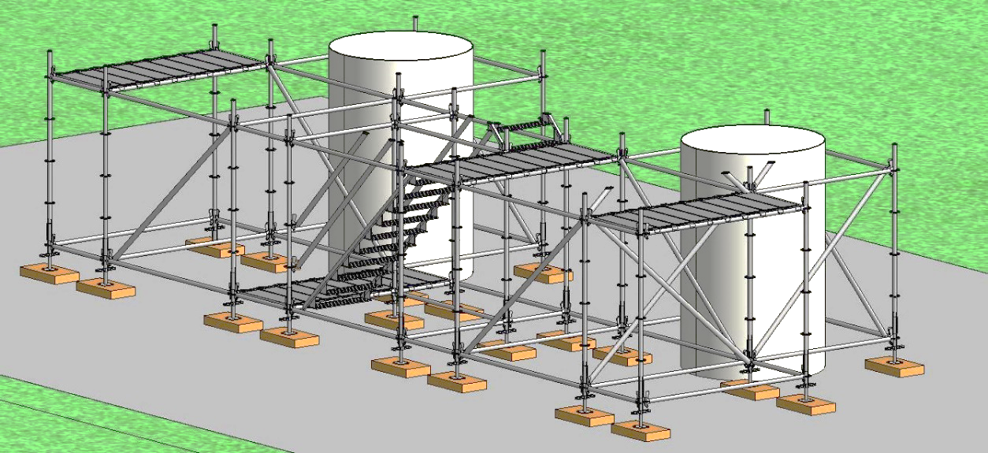
Figure1: Overview of the virtual scaffolding erection scenario

3.2 Experiment procedure and participants
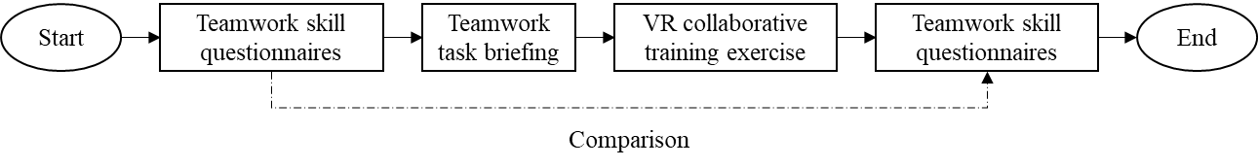
Figure 2 shows the evaluation process of the effect of VR operational training exercise on teamwork. All participants are required to complete the questionnaires related to teamwork skill competencies. Then they go through a collaborative task briefing to understand the details of the VR collaborative operation task. the participants need to complete the VR scaffolding erection in pairs. In the process of collaborative task completion, there is no requirement for the participants to complete the task, but the participant needs to experience teamwork through virtual operation. Finally, all participants are required again to complete the same questionnaires to evaluate the effect of VR operational training exercise on teamwork skills.
Figure 2: The evaluation process of VR operational training exercise on teamwork skill

In order to understand the effect of VR operational training exercise on construction team work, this study is conducted by survey research method. As Gall et al. (2003) stated that the method of survey research is to use questionnaires for data collection and the results of data analysis can be generalized. The teamwork skills questionnaire was developed by O’Neil et al., (1997), which is used to measure teamwork skill that involves coordination, decision making, leadership, interpersonal skills, adaptability and communication. The questionnaires are shown in Appendix 1. The participants are requested to assign a rating from 1 to 5 (1: very poor; 5: very good) to each question. In order to validate if there is significant difference on construction teamwork competencies after VR operational training exercise, a paired samples t-test at 0.05 significance level is adopted.

The participants in this experiment are 36 male undergraduate students who had no experience related to VR operation, but they all had teamwork experience. They are from the School of Engineering and Technology at Southwest University, China. The average age of them is 22.4 years old, with a rage of 21 to 23. The 36 participants are randomly divided into 18 groups, two students are in a group.

4. Results and discussions
The experiment results, including the before-after teamwork skills performance, the average score of coordination, decision making, leadership, interpersonal skill, adaptability and commutation were collected. The radar chart (Figure 3) illustrates the average values of teamwork skills in coordination, decision making, leadership, interpersonal, adaptability, and communication. Table 1 shows the details of teamwork skills scores. The average coordination scores before and after the training were 2.58 and 2.31, respectively; the average decision making scores were 2.66 and 2.87, respectively; the average leadership scores were 2.57 and 2.69, respectively; the average interpersonal skill scores were 3.22 and 3.35, respectively; the average adaptability scores were 2.63 and 3.24, respectively; the average communication scores were 2.90 and 3.11, respectively;
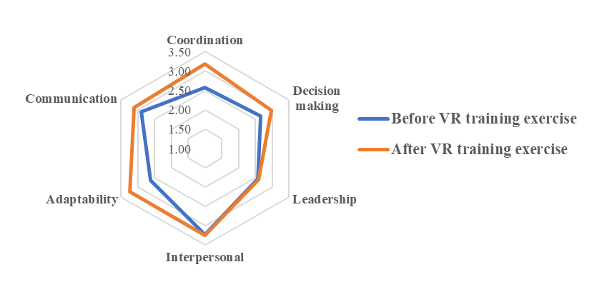
Figure 3: Average values of the questionnaire in teamwork skills

Table 1: The teamwork skills questionnaires score
 | Coordination |  | Decision making |  | Leadership |  | Interpersonal |  | Adaptability |  | Communication
Trainee No. | Before VR exercise | After  VR exercise | Before VR exercise | After VR exercise | Before VR exercise | After VR exercise | Before VR exercise | After VR exercise | Before VR exercise | After VR exercise | Before VR exercise | After VR exercise
1 | 2.50 | 3.25 | 2.50 | 3.00 | 2.25 | 2.25 | 3.00 | 3.00 | 2.25 | 2.75 | 2.75 | 3.00
2 | 3.25 | 3.50 | 3.75 | 3.75 | 3.75 | 3.75 | 3.50 | 3.50 | 3.75 | 3.75 | 3.50 | 3.50
3 | 2.75 | 3.50 | 2.75 | 3.00 | 2.00 | 2.25 | 3.00 | 3.00 | 2.75 | 3.25 | 3.00 | 3.00
4 | 3.25 | 3.50 | 2.75 | 3.25 | 3.00 | 3.00 | 3.75 | 3.75 | 3.00 | 3.25 | 3.50 | 3.50
5 | 2.75 | 3.25 | 3.00 | 3.25 | 2.00 | 2.00 | 3.75 | 3.75 | 2.25 | 3.00 | 3.50 | 3.50
6 | 2.75 | 3.25 | 3.00 | 3.00 | 2.75 | 2.75 | 3.00 | 3.00 | 2.75 | 3.00 | 2.75 | 2.75
7 | 2.50 | 3.50 | 2.75 | 3.25 | 2.25 | 2.25 | 3.00 | 3.00 | 2.25 | 2.75 | 2.75 | 2.75
8 | 2.75 | 3.25 | 2.75 | 3.00 | 2.75 | 2.75 | 3.00 | 3.00 | 2.75 | 2.75 | 3.00 | 3.00
9 | 2.25 | 3.25 | 2.75 | 2.75 | 3.00 | 3.00 | 3.25 | 3.25 | 3.50 | 3.50 | 3.00 | 3.25
10 | 3.00 | 3.50 | 2.75 | 3.00 | 2.75 | 2.75 | 3.00 | 3.00 | 2.50 | 3.50 | 3.50 | 3.50
11 | 3.00 | 3.50 | 2.50 | 3.25 | 2.00 | 2.00 | 4.00 | 4.00 | 3.00 | 3.00 | 3.50 | 3.75
12 | 2.25 | 3.00 | 2.25 | 2.50 | 2.00 | 2.00 | 3.00 | 3.00 | 1.75 | 2.75 | 2.25 | 3.00
13 | 2.75 | 3.25 | 2.50 | 3.25 | 2.50 | 2.50 | 3.75 | 3.75 | 2.00 | 2.75 | 3.50 | 3.50
14 | 3.25 | 3.50 | 3.00 | 3.25 | 3.75 | 3.75 | 3.50 | 3.75 | 3.00 | 3.25 | 3.50 | 3.50
15 | 3.00 | 3.50 | 2.50 | 2.75 | 3.25 | 3.25 | 3.25 | 3.25 | 2.50 | 3.50 | 3.25 | 3.25
16 | 2.00 | 2.50 | 2.00 | 2.50 | 2.00 | 2.00 | 4.00 | 4.00 | 3.25 | 3.50 | 4.00 | 4.00
17 | 2.00 | 2.50 | 2.00 | 2.25 | 3.00 | 3.00 | 3.25 | 3.25 | 2.25 | 3.25 | 3.00 | 3.25
18 | 2.75 | 3.25 | 2.75 | 3.00 | 2.50 | 2.50 | 3.25 | 3.25 | 3.00 | 3.00 | 3.00 | 3.25
19 | 2.50 | 3.25 | 3.00 | 3.25 | 2.75 | 2.75 | 3.50 | 3.50 | 3.00 | 3.50 | 3.25 | 3.25
20 | 2.75 | 3.25 | 3.00 | 3.25 | 2.75 | 2.75 | 3.25 | 3.25 | 3.25 | 3.50 | 3.00 | 3.00
21 | 2.25 | 3.25 | 2.25 | 2.75 | 2.75 | 2.75 | 3.00 | 3.00 | 2.75 | 3.25 | 2.50 | 2.75
22 | 2.25 | 3.00 | 2.75 | 3.25 | 2.50 | 2.50 | 3.00 | 3.00 | 2.00 | 3.00 | 2.00 | 3.00
23 | 2.50 | 2.75 | 3.00 | 3.00 | 3.00 | 3.00 | 3.00 | 3.25 | 3.50 | 3.50 | 3.00 | 3.25
24 | 2.25 | 3.25 | 2.75 | 3.00 | 2.00 | 2.25 | 3.00 | 3.00 | 3.00 | 3.25 | 3.00 | 3.00
25 | 3.00 | 3.00 | 2.50 | 3.25 | 2.75 | 2.75 | 3.00 | 3.00 | 2.75 | 3.25 | 3.00 | 3.00
26 | 3.00 | 3.00 | 2.75 | 3.00 | 2.75 | 2.75 | 3.25 | 3.25 | 3.00 | 3.75 | 2.50 | 2.75
27 | 2.75 | 3.25 | 3.00 | 3.00 | 3.00 | 3.00 | 3.00 | 3.00 | 2.50 | 3.75 | 3.25 | 3.25
28 | 2.25 | 3.00 | 2.50 | 2.75 | 2.00 | 2.00 | 3.00 | 3.25 | 2.00 | 3.50 | 2.75 | 2.75
29 | 2.00 | 2.50 | 2.75 | 3.00 | 2.50 | 2.50 | 3.25 | 3.25 | 2.75 | 3.25 | 2.00 | 2.75
30 | 2.25 | 3.00 | 2.75 | 3.00 | 3.00 | 3.00 | 3.00 | 3.00 | 3.00 | 3.25 | 3.00 | 3.00
31 | 2.50 | 3.25 | 2.25 | 3.00 | 2.00 | 2.00 | 3.00 | 3.00 | 2.00 | 3.00 | 2.00 | 2.75
32 | 2.00 | 3.25 | 2.25 | 2.50 | 2.00 | 2.00 | 3.00 | 3.00 | 1.25 | 3.00 | 2.00 | 2.75
33 | 2.25 | 3.25 | 2.50 | 2.50 | 2.50 | 2.50 | 3.25 | 3.25 | 3.25 | 3.50 | 1.50 | 3.00
34 | 2.75 | 3.25 | 2.00 | 2.75 | 2.00 | 2.25 | 3.00 | 3.00 | 2.25 | 3.50 | 3.00 | 3.00
35 | 2.25 | 3.00 | 2.75 | 2.75 | 2.00 | 2.00 | 3.25 | 3.25 | 2.00 | 3.50 | 3.00 | 3.00
36 | 2.75 | 3.25 | 2.75 | 3.00 | 2.75 | 2.75 | 3.00 | 3.00 | 2.00 | 3.00 | 2.25 | 2.50
AVG | 2.58 | 3.18 | 2.66 | 2.97 | 2.57 | 2.59 | 3.22 | 3.24 | 2.63 | 3.24 | 2.90 | 3.11

A paired samples t-test was used to evaluate if there was a significant difference of teamwork skills performance. The results of the t-test before and after VR training exercise is as shown in Table 2. VR training exercise is significant impact on coordination (t=-12.704; p=0<0.05), decision making (t=-8.002; p=0<0.05), adaptability (t=-7.584; p=0<0.05), and communication (t=-3.645; p=0.001<0.05). However, the leadership (t=-1.784; p=0.083>0.05) and interpersonal skill (t=-1.784; p=0.083>0.05) was not significantly different after VR training exercise. All the comparative t-tests results have been validated through Cohen’s benchmark (Cohen, 1988). The value of Cohen’s d for 95% confidence interval was tested on a scale of medium to large size effect which is 1.83 for coordination, 0.95 for decision making, and 0.79 for leadership, 0.06 for interpersonal skill, 1.35 for adaptability and 0.46 for communication.

Table 6-2: The paired samples test results
 | Paired Differences |  |  |  |  | $$t$$ | $$df$$ | $p$ value
 | Mean | Std. Deviation | Std. Error Mean | 95% Confidence Interval of the Difference
 |  |  |  | Lower | Upper
Coordination | -0.597 | 0.282 | 0.047 | -0.693 | -0.502 | -12.70 | 35 | 0
Decision making | -0.313 | 0.234 | 0.039 | -0.392 | -0.233 | -8.002 | 35 | 0
Leadership | -0.021 | 0.070 | 0.012 | -0.045 | 0.003 | -1.784 | 35 | 0.083
Interpersonal | -0.021 | 0.070 | 0.012 | -0.045 | 0.003 | -1.784 | 35 | 0.083
Adaptability | -0.611 | 0.483 | 0.081 | -0.775 | -0.448 | -7.584 | 35 | 0
Communication | -0.215 | 0.354 | 0.059 | -0.335 | -0.095 | -3.645 | 35 | 0.001

As can be seen Table 1 and Table 2, the significant improvement of after VR collaborative training exercise includes coordination, decision making, and adaptability. The average scores of leadership and interpersonal skill have not been improved significantly compared with other teamwork skills categories. This shows that there is no significant difference between before-after VR collaborative training exercises for trainees to improve how to drive the scaffolding construction project to completion and interact cooperatively with team member. The advantages of VR collaborative training exercises are that it helps the trainees enhance the ability of organizing team activities and make decision by useful information to solve the problem. As stated by one of the participants: “Although I did teamwork project before, I could not organise training activities to achieve the training task with my teammate when I operated the scaffolding foundation erection and ground-floor scaffolding erection in virtual environment. However, after a period of VR operation, my teammate and I were able to recognize problems to make team decisions. It really helps me understand more about teamwork through VR practice.”
Even though the average scores of the leadership and interpersonal skills were not significantly different after VR training exercise, the trainees learned through the VR collaborative training exercise that an efficient teamwork needs a good leader to drive the task completion. Based on the observation of the experiment, if a participant was surrounded by people of high competency level, he/she could strive to show his/her potential. Selecting the team members will not automatically make them effectively work as a team. As stated by one of participants: “Although VR training exercise has no impact on my leadership and interpersonal skills, the VR collaborative training makes me deeply understand that if you want to create and manage a team, selecting the team members should not only look for technical skills, but also interpersonal skills.”

5. Conclusions and limitations
The questionnaire results indicate that VR collaborative training exercise can have positive effect on teamwork skills, especially in coordination, decision making, adaptability and communication. Although the results show there is no significant difference in leadership and interpersonal skills after VR collaborative training exercise, the trainees realise that if relationship between the participants becomes strained, this could result in a task becoming unsuccessful.
This VR collaborative training exercise is a relatively small scaffolding scenario and only two trainees work as a team. In reality, the scaffolding construction task may be completed by more than two scaffolders with the potential of cooperation. In addition, only scaffolding erection process is adopted for evaluation. Potential research can include more complicated operation simulation.

6. Acknowledgement
This study was funded by Chongqing Technology Innovation and Application Development Project (csts2020jscx-msxmX0082) and Education and Teaching Reform Research Project of Southwest University, China. (2020JY022)

7. Reference
Zhao, X., Zuo, J., Wu, G., & Huang, C. (2019). A bibliometric review of green building research 2000–2016. Architectural Science Review, 62(1), 74-88.
Du, J., Shi, Y., Zou, Z., & Zhao, D. (2017). CoVR: Cloud-based multiuser virtual reality headset system for project communication of remote users. Journal of construction engineering and management, 144(2), 04017109.
Vahdatikhaki, F., El Ammari, K., Langroodi, A. K., Miller, S., Hammad, A., & Doree, A. (2019). Beyond data visualization: A context-realistic construction equipment training simulators. Automation in construction, 106, 102853
Mitropoulos, P., & Memarian, B. (2012). Team processes and safety of workers: Cognitive, affective, and behavioral processes of construction crews. Journal of construction engineering and management, 138(10), 1181-1191.
Sung, H.-Y., & Hwang, G.-J. (2013). A collaborative game-based learning approach to improving students' learning performance in science courses. Computers & Education, 63, 43-51.
Hummel, H. G., Van Houcke, J., Nadolski, R. J., Van der Hiele, T., Kurvers, H., & Löhr, A. (2011). Scripted collaboration in serious gaming for complex learning: Effects of multiple perspectives when acquiring water management skills. British Journal of Educational Technology, 42(6), 1029-1041.
Le, Q.T.; Pedro, A.; Pham, H.C.; Park, C.S. (2016). A Virtual World Based Construction Defect Game for Interactive and Experiential Learning. International Journal of Engineering Education. 32, 457–467.
Lorenzo, C.-M., Sicilia, M. Á., & Sánchez, S. (2012). Studying the effectiveness of multi-user immersive environments for collaborative evaluation tasks. Computers & Education, 59(4), 1361-1376.
Gall, M., Gall, J., & Borg, W. (2003). Educational research: An introduction (7th ed.). Boston: Allen and Bacon.
O’Neil, H., Allred, K., & Baker, E. L. (1997). Review of workforce readiness theoretical frameworks. Workforce readiness: Competencies and assessment, 3-25.

